**RRJETAT E KOMPJUTERAVE 1**

**LAB 5**

**Tema:** Konfigurimi i nje Topologjie Rrjeti duke perdorur Distance Vector Routing protocol (IPv4, Ipv6)

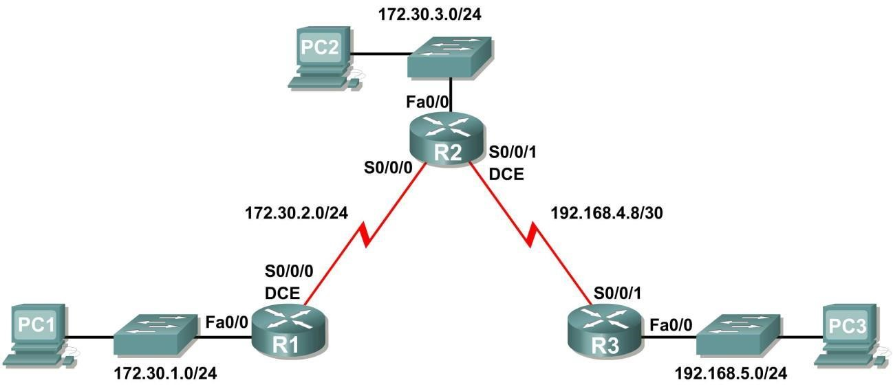

**Skenari –** Ekzekutimi i RIPv1 me Subnet-e dhe midis Classfull Networks

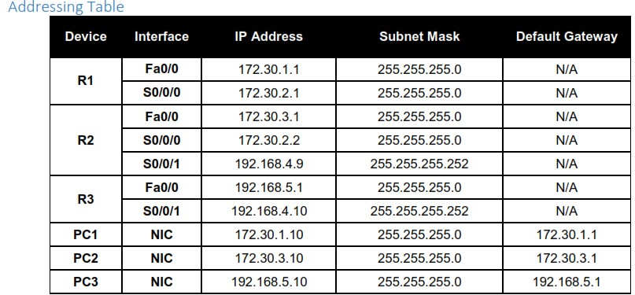

**Task 1: Make Changes between Scenario A and Scenario B**

**Step 1:** Change the IP addressing on the interfaces as shown in the Topology Diagram and the AddressingTable.

Sometimes when changing the IP address on a serial interface, you may need to reset that interface by using the

**shutdown** command, waiting for the LINK-5-CHANGED message, and then using the **no shutdown** command.

This process will force the IOS to starting using the new IP address.

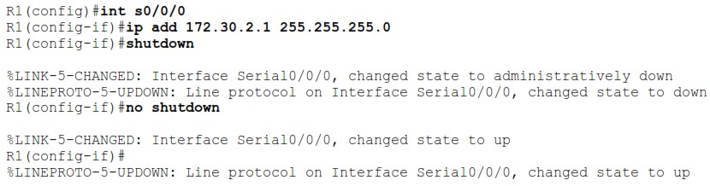

**Step 2:** Verify that routers are active.

After reconfiguring all the interfaces on all three routers, verify that all necessary interfaces are active with the **show ip interface brief** command.

**Step 3:** Remove the RIP configurations from each router.

Although you can remove the old **network** commands with the **no** version of the command, it is more efficient to simply remove RIP and start over. Remove the RIP configurations from each router with the **no router rip** global configuration command. This will remove all the RIP configuration commands including the **network** commands.

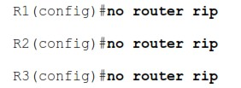

**Task 2: Configure RIP**

**Step 1:** Configure RIP routing on R1 as shown below.

*R1(config)#****router rip***

*R1(config-router)#****network 172.30.0.0***

Notice that only a single network statement is needed for R1. This statement includes both interfaces on different subnets of the 172.30.0.0 major network.

**Step 2:** Configure R1 to stop sending updates out the FastEthernet0/0 interface.

Sending updates out this interface wastes the bandwidth and processing resources of all devices on the LAN. In addition, advertising updates on a broadcast network is a security risk. RIP updates can be intercepted with packet sniffing software. Routing updates can be modified and sent back to the router, corrupting the router table with false metrics that misdirects traffic.

The **passive-interface fastethernet 0/0** command is used to disable sending RIPv1 updates out that interface. When you are finished with the RIP configuration, return to privileged EXEC mode and save the current configuration to NVRAM.

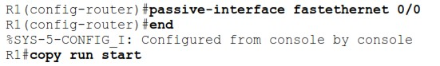

**Step 3:** Configure RIP routing on R2 as shown below.

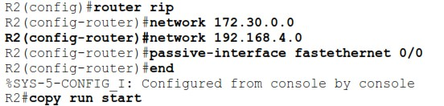

Again notice that only a single network statement is needed for the two subnets of 172.30.0.0. This statement includes both interfaces, on different subnets, of the 172.30.0.0 major network. The network for the WAN link between R2 and R3 is also configured.

When you are finished with the RIP configuration, return to privileged EXEC mode and save the current configuration to NVRAM.

**Step 4:** Configure RIP routing on R3 as shown below.

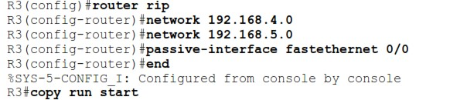

When you are finished with the RIP configuration, return to privileged EXEC mode and save the current configuration to NVRAM.

**Task 3: Verify RIP Routing**

**Step 1:** Use the show ip route command to verify that each router has all of the networks in the topology in the routing table.

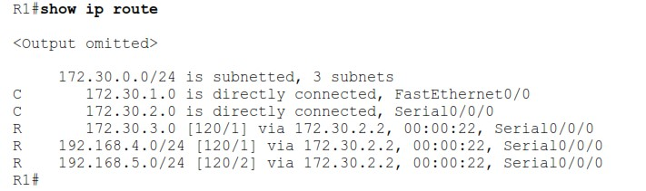

**Note:** RIPv1 is a classful routing protocol. Classful routing protocols do not send the subnet mask with network in routing updates. For example, 172.30.1.0 is sent by R2 to R1 without any subnet mask information.

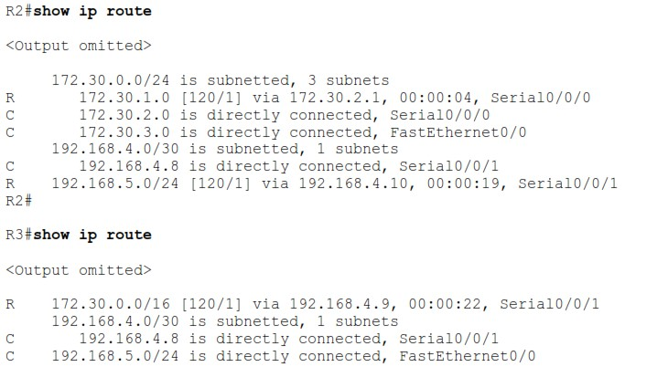

**Step 2:** Verify that all necessary interfaces are active.

If one or more routing tables does not have a converged routing table, first make sure that all necessary interfaces are active with **show ip interface brief**.

Then use **show ip protocols** to verify the RIP configuration. Notice in the output from this command that the FastEthernet0/0 interface is no longer listed under **Interface** but is now listed under a new section of the output:

**Passive Interface(s)**.

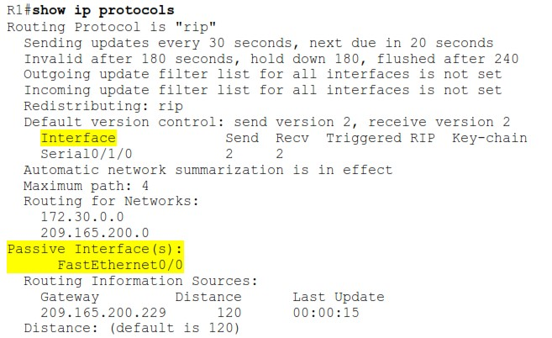

**Step 3:** View the RIP messages being sent and received.

To view the RIP messages being sent and received use the **debug ip rip** command. Notice that RIP updates are not sent out of the fa0/0 interface because of the **passive-interface fastethernet 0/0** command.

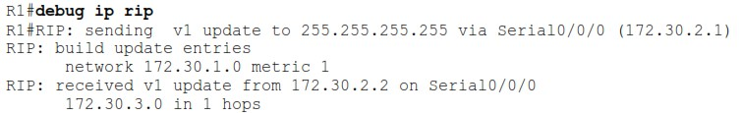

**Step 4:** Discontinue the debug output with the undebug all command.



**Task 1: Make Changes between Scenario A and Scenario B**

**Step 1,2:**

Konfigurojme sipas kërkesës gjithë IP dhe paraqesim skemën ne fund.

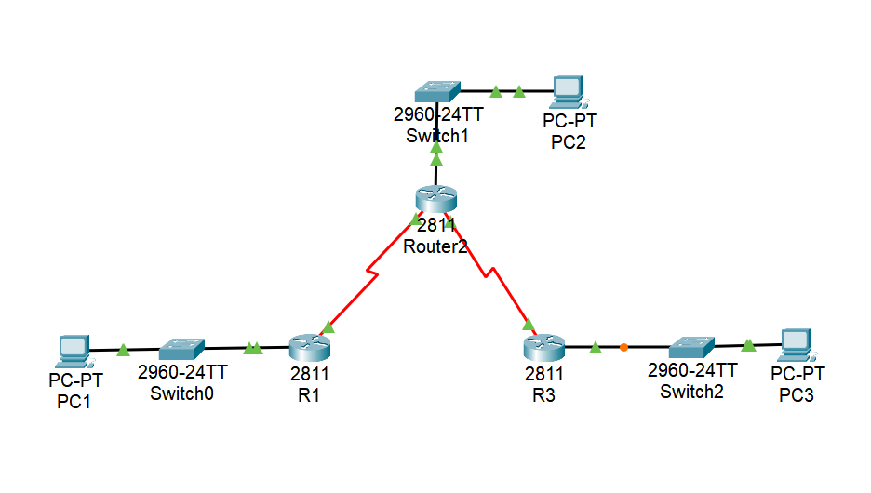

Step 3:

Heqim rip configuration.







**Task 2: Configure RIP**

Step 1,2:

Step 3:

Step 4:

**Task 3: Verify RIP Routing**

Step 1:

Step 2:

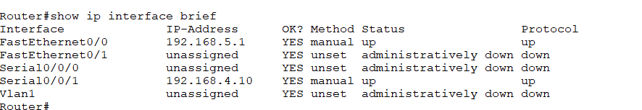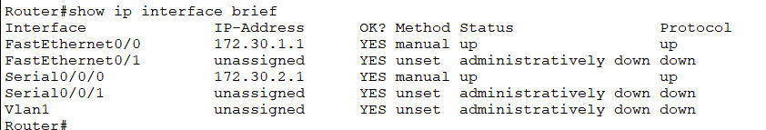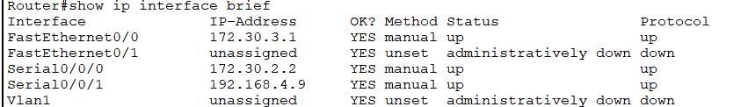

Step 3,4:

